2020年CTCC中国房车锦标赛
超级杯车型注册表-副表2 官方车架套件注册表
2020 China Touring Car Championship
HOMOLOGATION FORM FOR MODLE IN SUPER CUP
-APPENDIX 2 OFFICIAL CHASSIS KIT

车型注册号码/HOMOLOGATION NUMBER

CTCC-XXX-2001-YYY-ZZZ-A

官方车架套件注册号码/OFFICIAL CHASSIS KIT HOMOLOGATION NUMBER

CTCCOC-XXX-YYY-ZZZ-2001

注册人/APPLICANT

XXX

注册有效期/ HOMOLOGATION VAILD

2020年

审核人/AUDIT SIGNATURE
姓名  签字 | 姓名  签字 | 姓名  签字

1. 一般项目/ GENERAL

1.1. 制造商/ MANUFACTURER

填写/Description

1.2. 车型和类型/ MODEL AND TYPE
a）车型和类型/ Model and type | 填写/Description
b）车架号码/ Typical chassis number | 填写/Description

2. 成品尺寸/ FINISHED DIMENSIONS

2.1. 轮距/ WHEELTRACK
a）在前轮顶点12点钟位置  At front wheel top at 12 o’clock | 填写/Description mm +0/-1%
a）在后轮顶点12点钟位置  At rear wheel top at 12 o’clock | 填写/Description mm +0/-1%

2.2. 轴距/ WHEELBASE

填写/Description ±10 mm

3. 防滚架/ ROLLCAGE

3.1. 防滚架/ ROLLCAGE
a）管材材质/Tube material | 铬钼合金钢
b）管材尺寸/Tube size | A | B
 | 40mm | 30mm
b1）管材数量/Number of tubes | 填写/Description | 填写/Description

I3-1）防滚架设计图
Drawing of the rollcage

4. 车身 - 底盘（车身壳体）/ BODYWOR - CHASSIS（BODYSHELL）

4.1. 底盘（车架）/ CHASSIS（BODYSHELL）
车架改装（对车身钣金件）/ MODIFICATIONS OF CHASSIS（BODYSHELL）
P4-1）前舱壁 – 改装转向柱开口 P4-2）前梁 – 改装以容纳防倾杆轴承
Front bulkhead Front member
- Modification for steering column passage - Modification for the anti-roll bar bearing
添加照片  Photo | 添加照片  Photo
P4-3）前梁 – 改装以匹配发动机悬置 P4-4）前梁 – 改装以匹配发动机悬置
Front member Front member
- Modification for engine support - Modification for the engine support
添加照片  Photo | 添加照片  Photo
P4-5）后梁 – 改装以容纳防倾杆轴承 P4-6）前悬挂塔顶 – 顶部安装位置
Rear member Front suspension turret
- Modification for the anti-roll bar bearing - Top mount
添加照片  Photo | 添加照片  Photo
P4-7）前悬挂塔顶 – 顶部安装位置 P4-8）前悬挂 – 车身钣金件的改装
Front suspension turret Front suspension mount
- Top mount - Modification of bodywork panels
添加照片  Photo | 添加照片  Photo

P4-9）前梁 – 改装以匹配副车架 P4-10）前梁 – 改装以匹配车架
Front member Front member
- Modification for subframe - Modification for subframe
添加照片  Photo | 添加照片  Photo
P4-11）后梁 – 改装以匹配副车架 P4-12）后梁 – 改装以匹配车架
Rear member Rear member
- Modification for subframe - Modification for subframe
添加照片  Photo | 添加照片  Photo

P4-13）后悬挂塔顶 – 顶部安装位置 P4-14）后悬挂安装 – 车身钣金件的改装
Rear suspension Rear suspension mount
- Top mount - Modification of bodywork panels
添加照片  Photo | 添加照片  Photo

补充信息/ COMPLEMENTARY INFORMATION
P4-15）其他车身钣金件的改装1 P4-16）其他车身钣金件的改装2
Other modification of bodywork panels 1 Other modification of bodywork panels 2
添加照片  Photo | 添加照片  Photo
获批准文件编号：  Approved by document No. ：No. | 获批准文件编号：  Approved by document No. ：No.

5. 前后桥和悬架/ AXLES AND SUSPENSION
前轮/ FRONT
P5-1）副车架 – 拆下状态 I5-1）副车架 – 图
Subframe for fixing the axle parts Subframe for fixing the axle parts
- Dismounted - Drawing
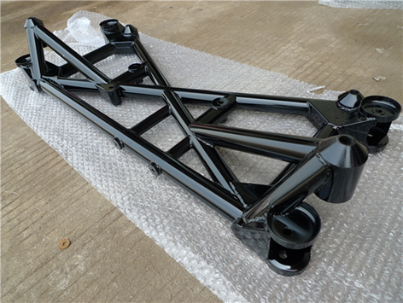  Photo  添加照片 |  | 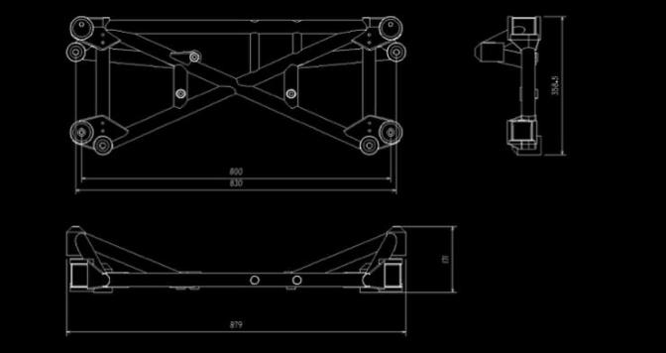  绘图和尺寸  Drawing with dimensions
产品编号/Part No. | 130-D6001 | 最小重量/Min. weigh | 8.25 kg
P5-2）副车架 – 编号标签
Subframe - Label

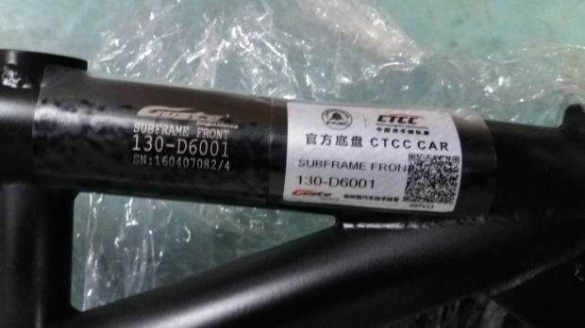
Photo

添加照片

I5-2）副车架 – 悬架安装点 I5-3）副车架 – 悬架安装点
Subframe- Axle mounting points Subframe- Axle mounting points
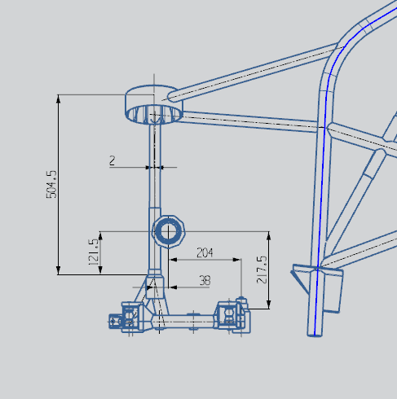 | 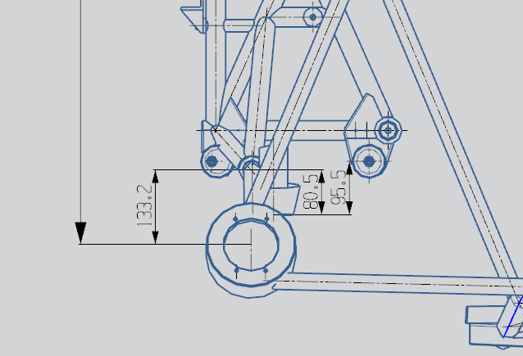
I5-4）副车架 – 悬架安装点 I5-5）副车架 – 悬架安装点
Subframe- Axle mounting points Subframe- Axle mounting points
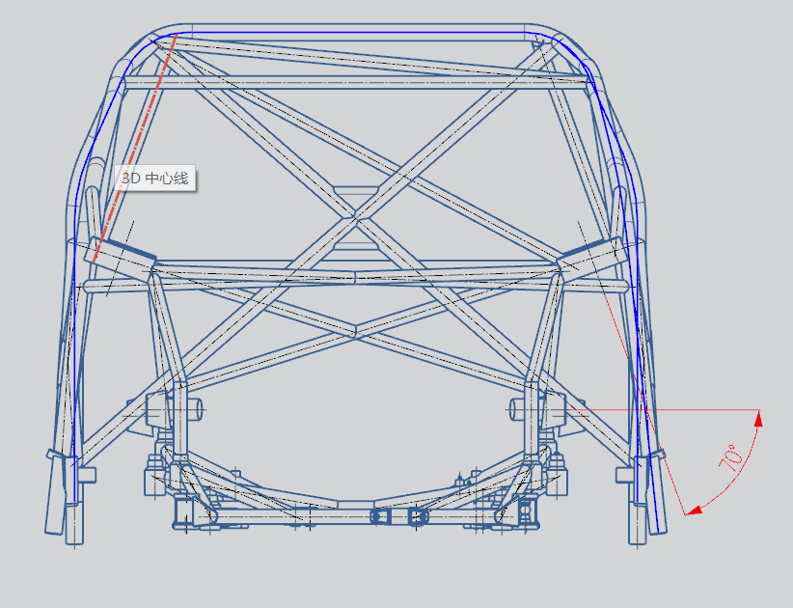 | 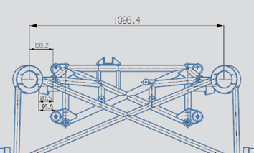

P5-3）转向节（立柱） – 拆下状态 I5-6）转向节（立柱） – 图
Bare hub-carrier - Dismounted Bare hub-carrier - Drawing
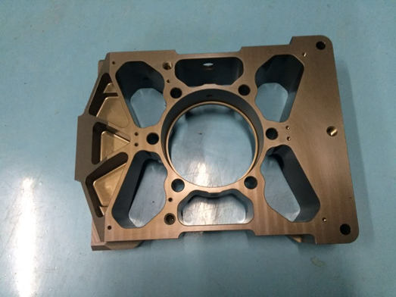  添加照片  Photo |  | 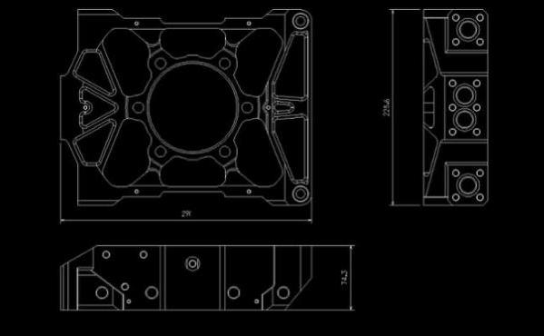  绘图和尺寸  Drawing with dimensions
材质/Material |  | 铝合金
产品编号/Part No. | 130-D1015 | 最小重量/Min. weigh | 2930.4 g
P5-4）转向节（立柱） – 编号标签
Bare hub-carrier - Label

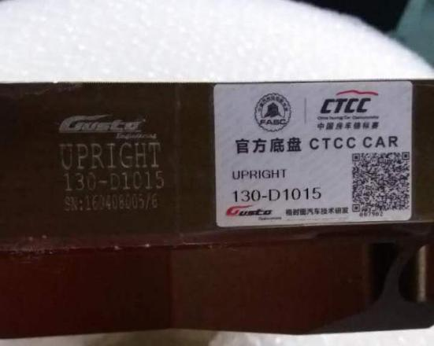
添加照片

Photo

P5-5）完整的下横臂 – 拆下状态 I5-7）完整的下横臂 – 图
Complete wishbone/arm - Dismounted Complete wishbone/arm - Drawing
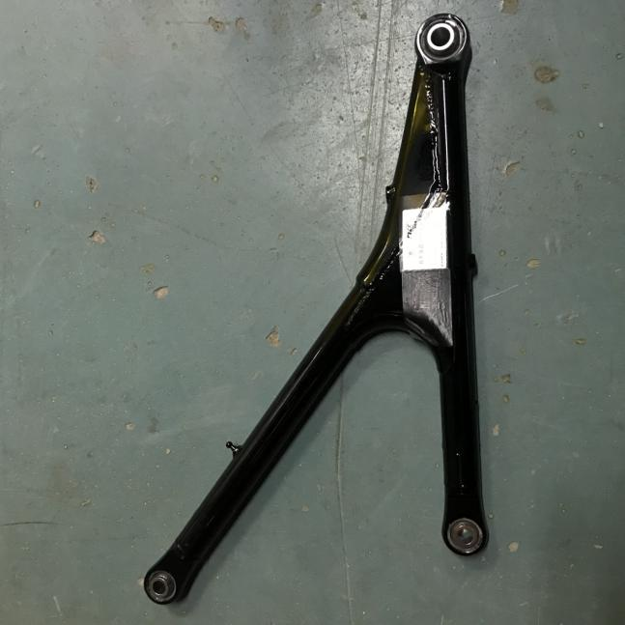 | 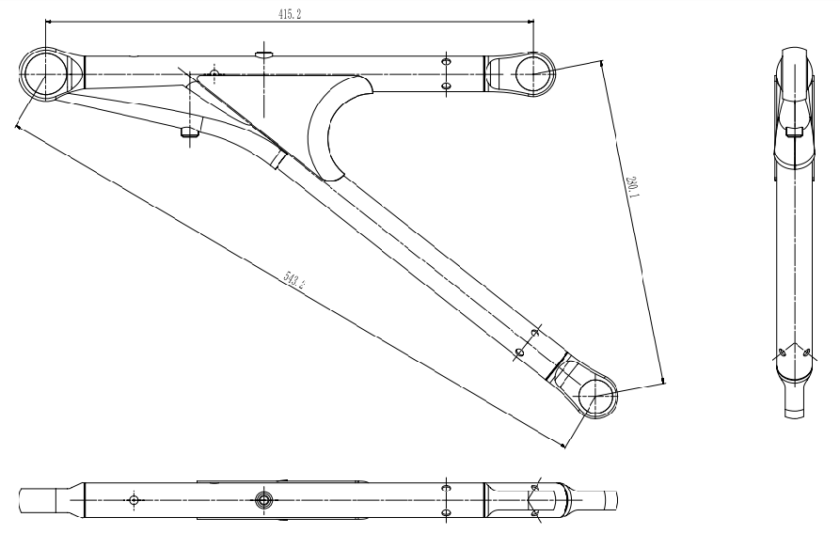
材质/Material | 铬钼合金钢
产品编号/Part No. | 170-D7008-V4
最小重量/Min. weight | 2260 g（带轴承/with bearings）
P5-6）完整的下横臂 – 编号标签
Complete wishbone/arm - Label

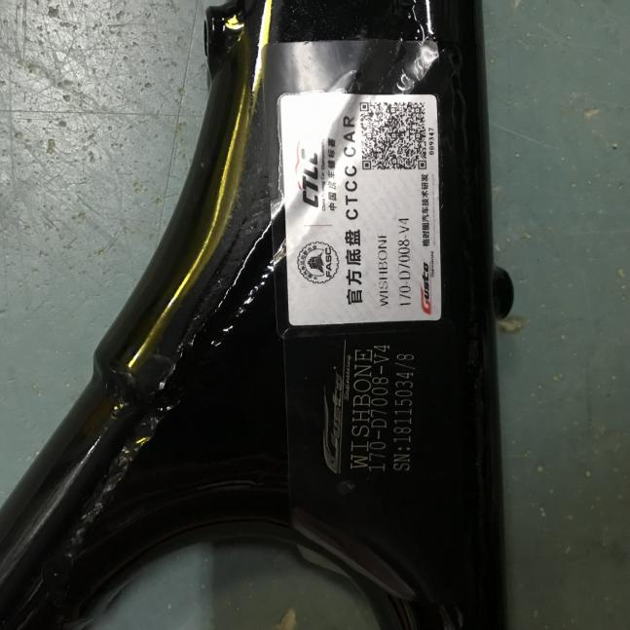
P5-7）避震器塔顶轴承座 – 拆下状态 P5-8）避震器塔顶轴承座 – 编号标签
Housing BRG damper - Dismounted Housing BRG damper - Label
 |  | 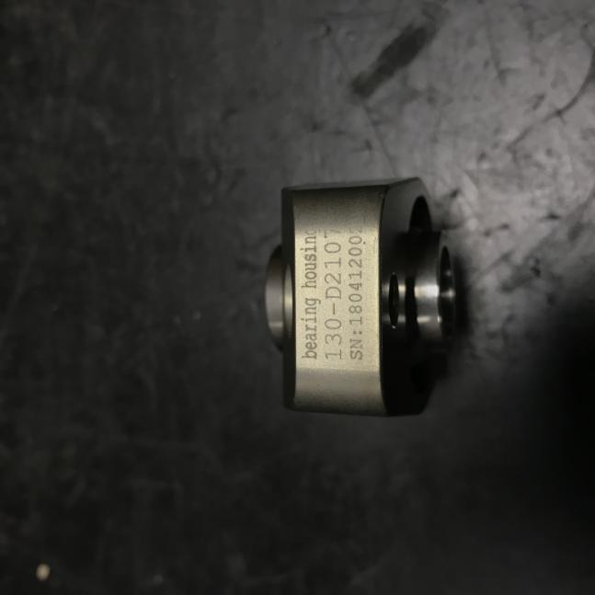
产品编号/Part No. | 130-D2107 | 最小重量/Min. weigh | 65.8 g

注：配套KW Competition 3way避震器的此部件请见副表1-官方指定产品注册表
P5-9）避震脚 – 拆下状态 I5-8）避震脚 – 图
Damper bracket - Dismounted Damper bracket - Drawing
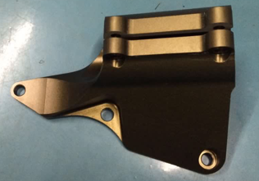 |  | 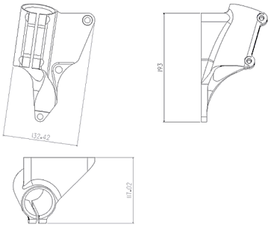
材质/Material |  | 铝合金
产品编号/Part No. | 130-D2005 | 最小重量/Min. weigh | 582.28 g
P5-10）避震脚 – 编号标签
Damper bracket - Label
P5-11）车轮轴承– 拆下状态 P5-12）车轮轴承 – 编号标签
Bearing - Dismounted Bearing - Label
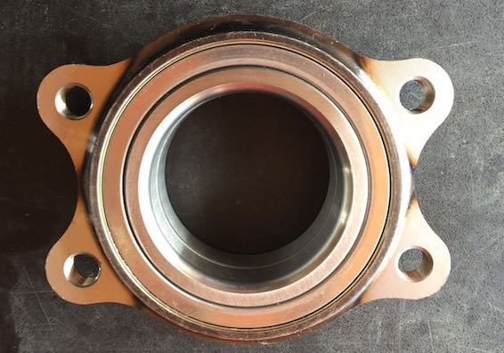 |  | 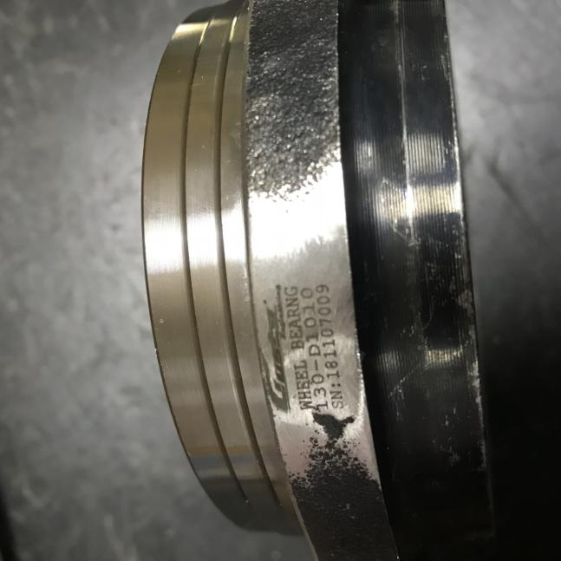
产品编号/Part No. | 130-D1010 | 最小重量/Min. weigh | 1341 g

P5-13）车轮法兰 – 拆下状态 P5-14）车轮法兰 – 编号标签
HUB ASSY WELEDE - Dismounted HUB ASSY WELEDE - Label
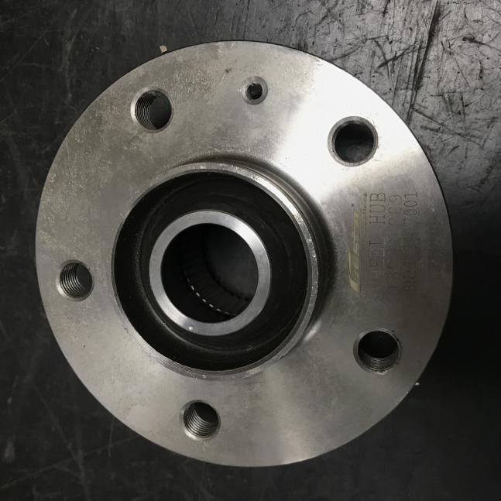 |  | 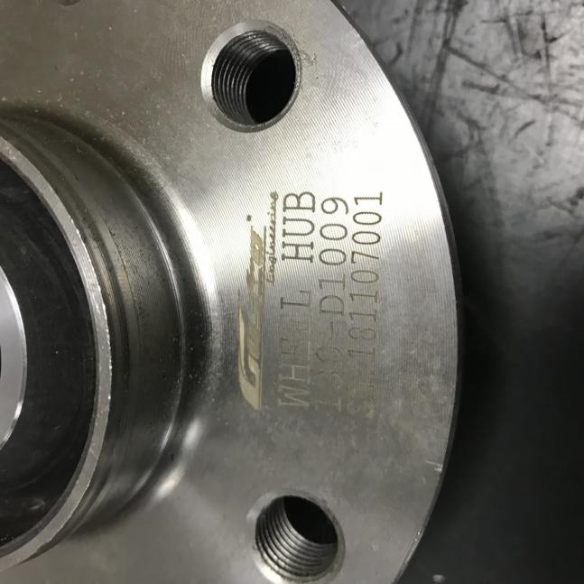
产品编号/Part No. | 130-D1009 | 最小重量/Min. weigh | 1650.4 g
P5-15）车轮螺栓 – 拆下状态 P5-16）车轮螺栓 – 编号标签
Wheel bolt - Dismounted Wheel bolt - Label
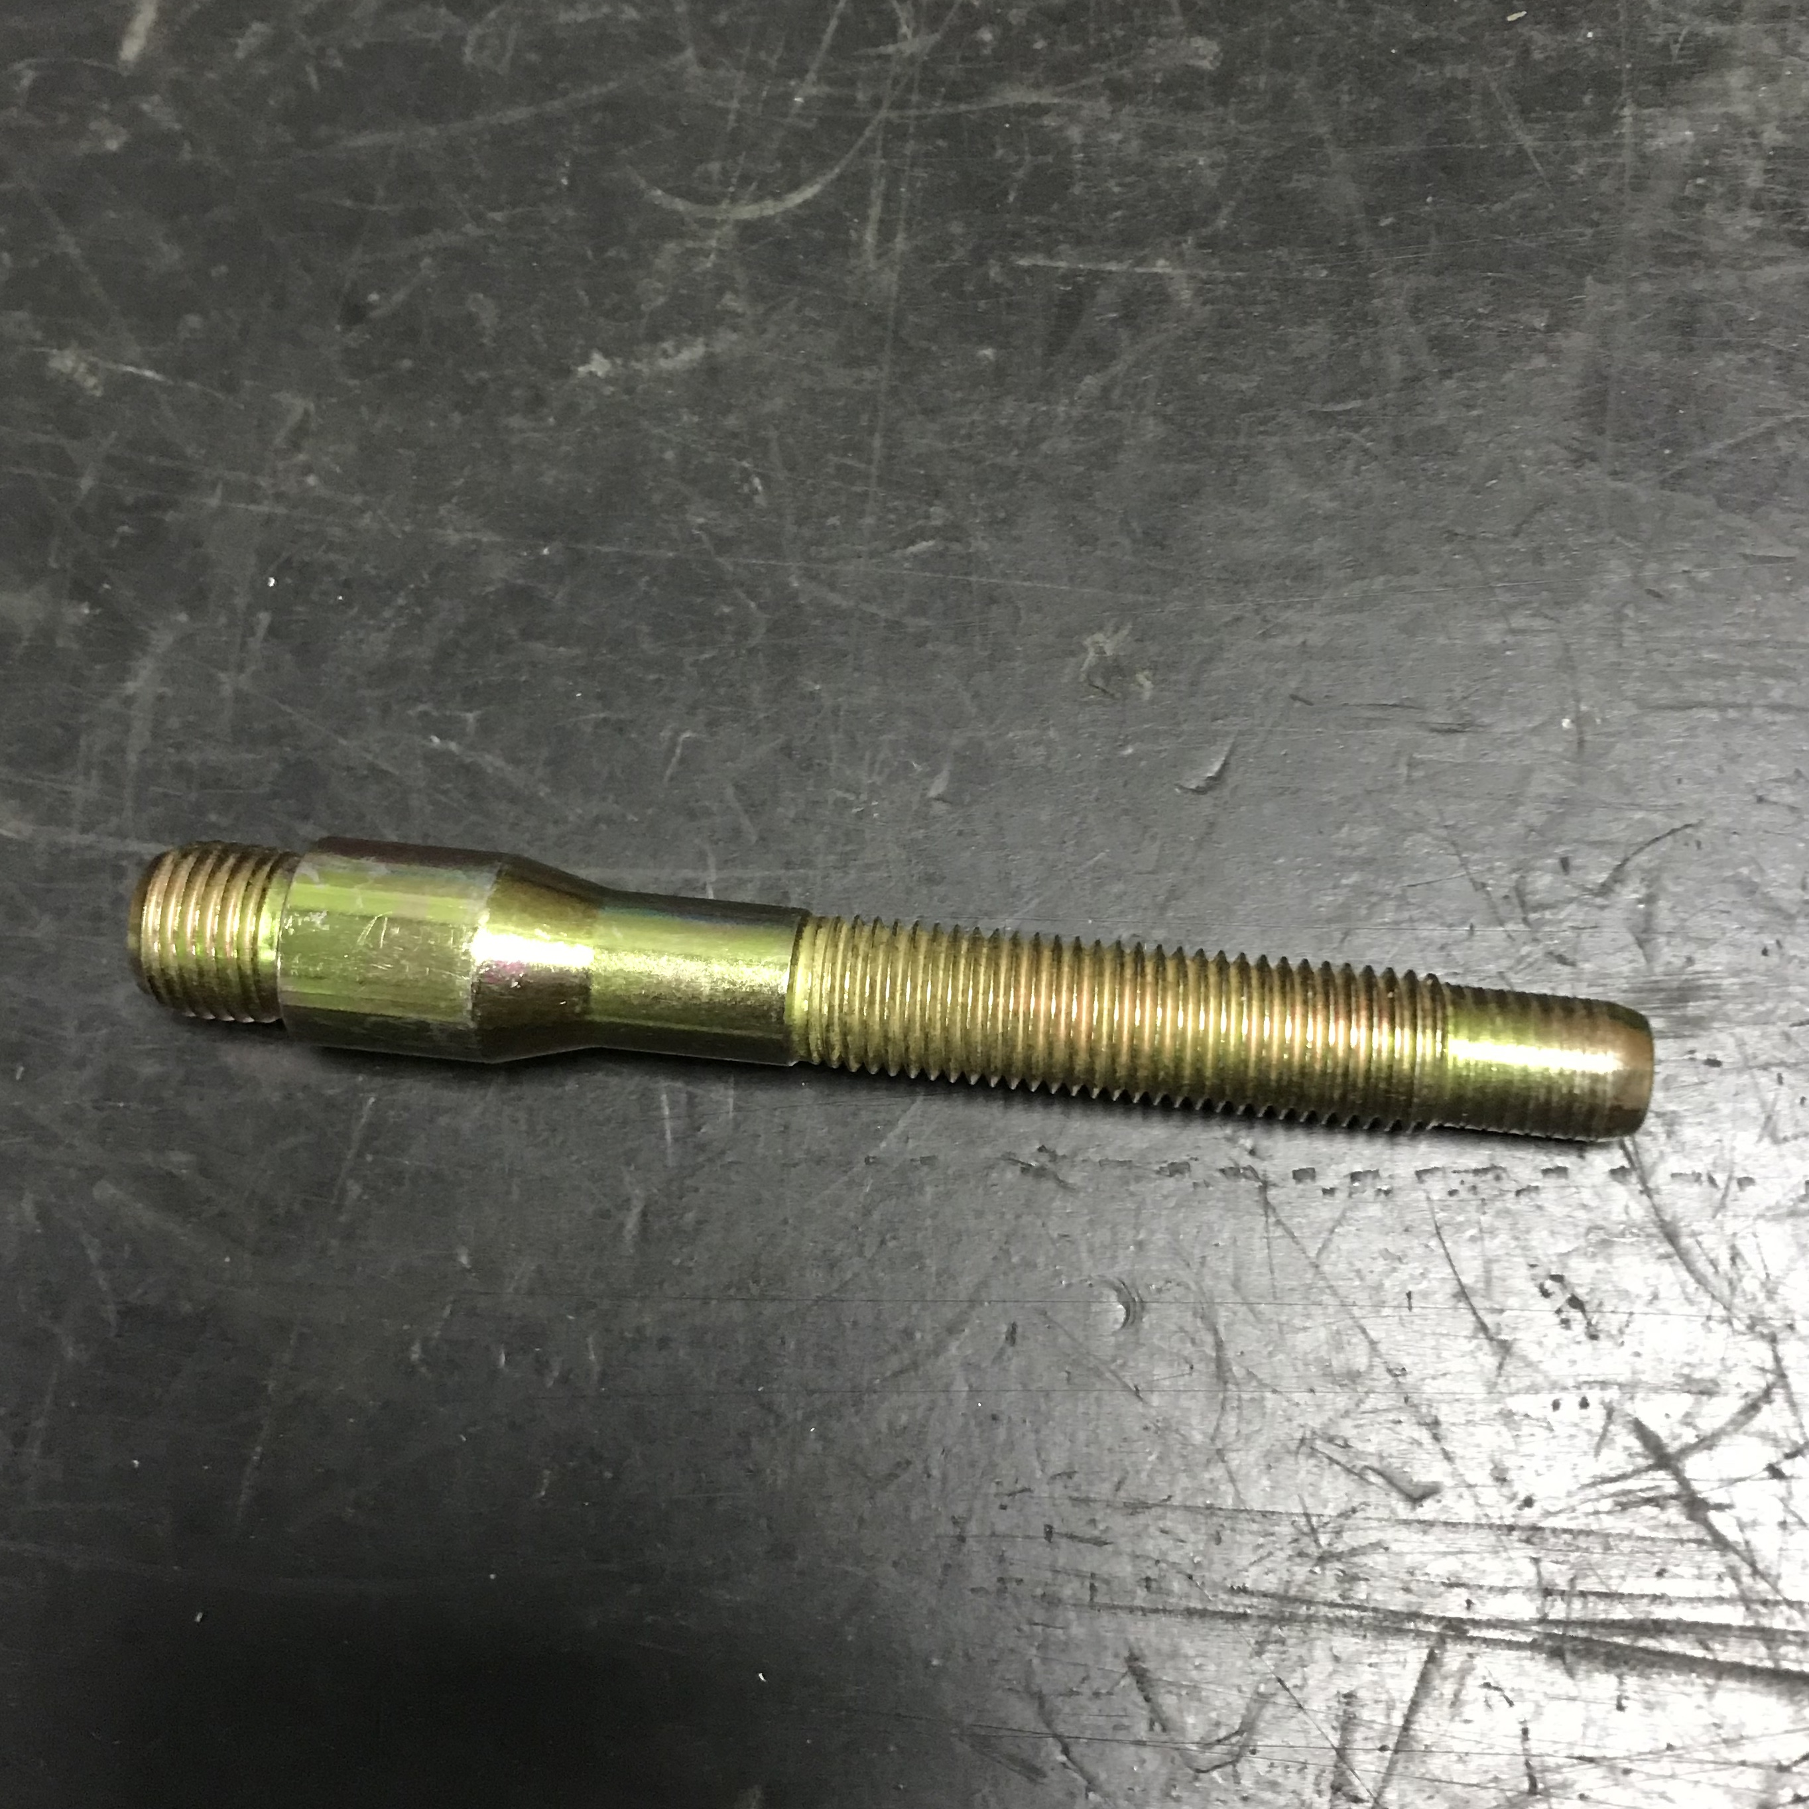 |  | 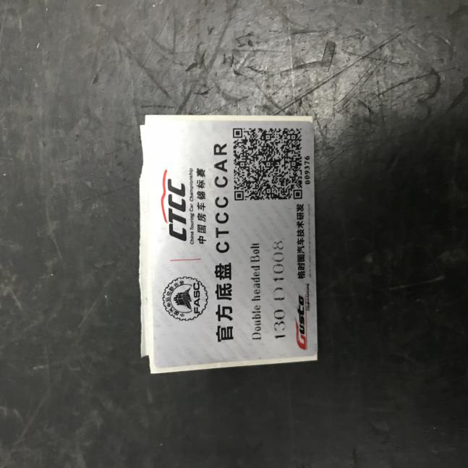
产品编号/Part No. | 130-D1008 | 最小重量/Min. weigh | 100 g

P5-17）转向拉杆座 – 拆下状态 P5-18）转向拉杆座– 编号标签
Bracket steering arm bracket - Dismounted Bracket steering arm bracket - Label
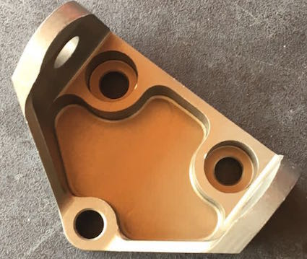 |  | 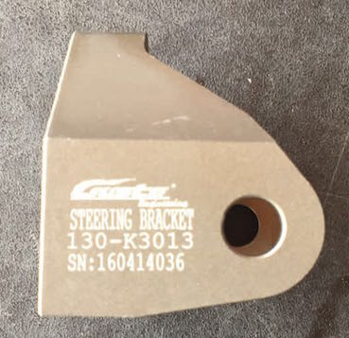
产品编号/Part No. | 130-K3013 | 最小重量/Min. weigh | 84.22 g
P5-19）下摇臂座 – 拆下状态 P5-20）下摇臂座 – 编号标签
Wish bone bracket - Dismounted Wish bone bracket - Label

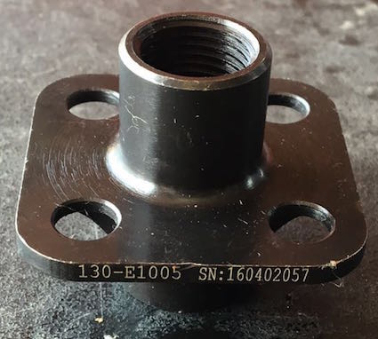
产品编号/Part No. | 130-E1005 | 最小重量/Min. weigh | 85 g

P5-21）转向拉杆 – 拆下状态 P5-22）转向拉杆 – 编号标签
Track rod inboard - Dismounted Track rod inboard - Label
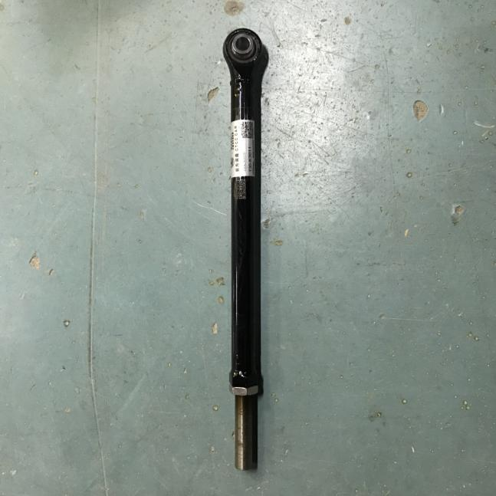 |  | 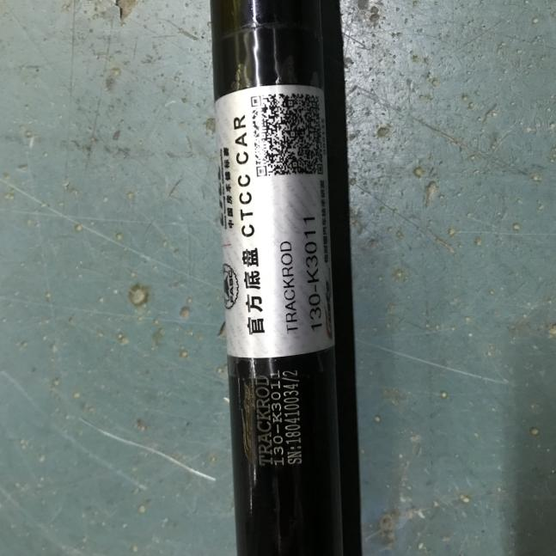
产品编号/Part No. | 130-K3011 | 最小重量/Min. weigh | 610.5 g
P5-23）前防倾杆拉杆 – 拆下状态 P5-24）前防倾杆拉杆 – 编号标签
Front arb arm - Dismounted Front arb arm - Label
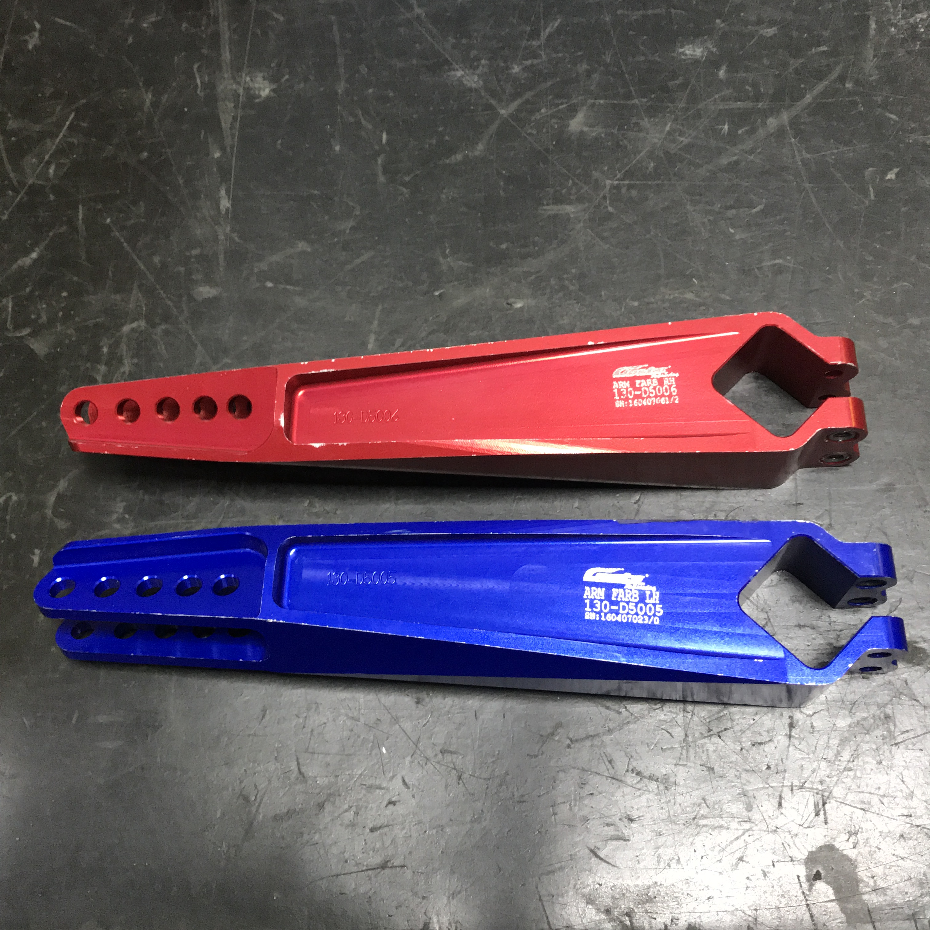 |  | 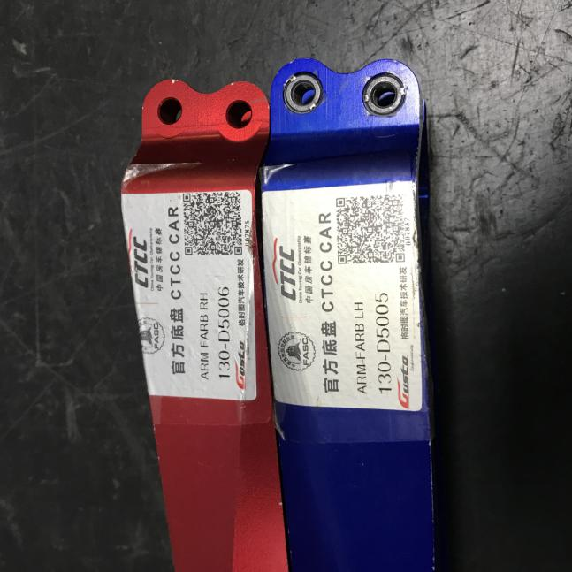
产品编号/Part No. | 130-D5005\130-D5006 | 最小重量/Min. weigh | 380.2/390.3 g

后轮/ REAR
P5-25）副车架 – 拆下状态 I5-9）副车架 – 图
Subframe for fixing the axle parts Subframe for fixing the axle parts
- Dismounted - Drawing
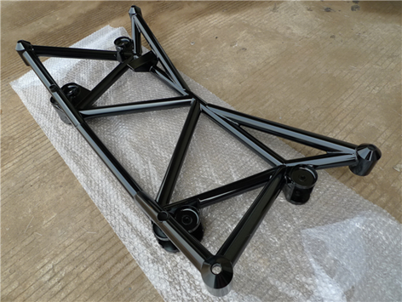  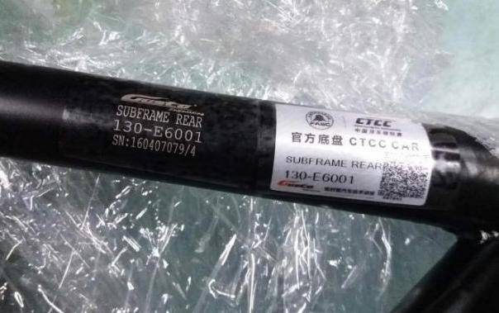  添加照片  Photo |  | 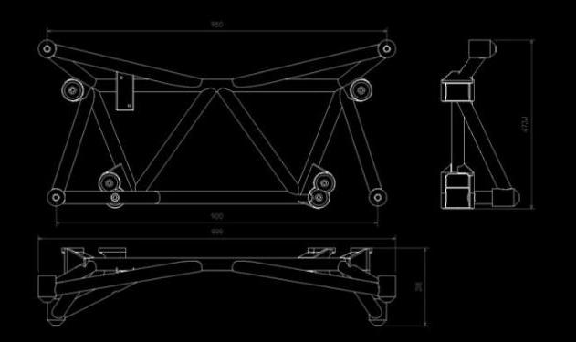  绘图和尺寸  Drawing with dimensions
产品编号/Part No. | 130-E6001 | 最小重量/Min. weigh | 6.74 kg
P5-26）副车架 – 编号标签
Subframe - Label

添加照片

Photo

I5-10）副车架 – 悬架安装点 I5-11）副车架 – 悬架安装点
Subframe- Axle mounting points Subframe- Axle mounting points
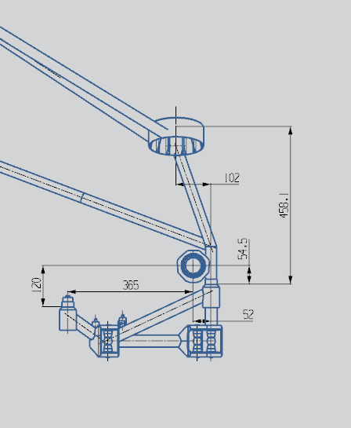 | 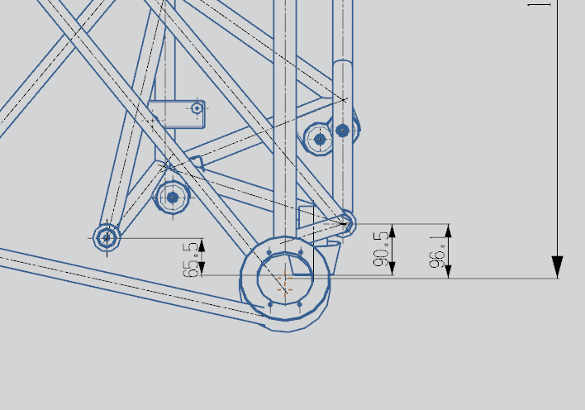
I5-12）副车架 – 悬架安装点 I5-13）副车架 – 悬架安装点
Subframe- Axle mounting points Subframe- Axle mounting points

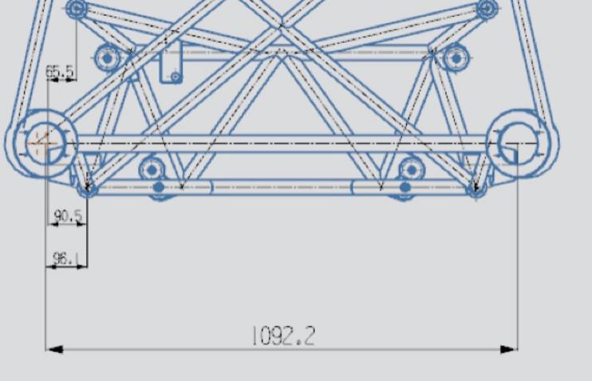

P5-27）转向节（立柱） – 拆下状态 I5-14）转向节（立柱） – 图
Bare hub-carrier - Dismounted Bare hub-carrier - Drawing
添加照片  Photo |  | 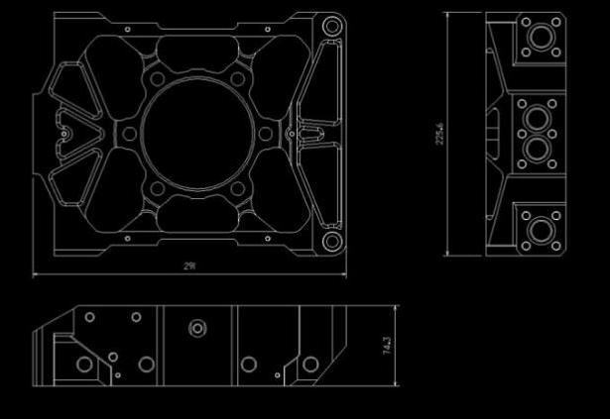  绘图和尺寸  Drawing with dimensions
材质/Material |  | 铝合金
产品编号/Part No. | 13-D1015 | 最小重量/Min. weigh | 2930.4 g
P5-28）转向节（立柱） – 编号标签
Bare hub-carrier - Label

添加照片

Photo

P5-29）完整的下横臂 – 拆下状态 I5-15）完整的下横臂 – 图
Complete wishbone/arm - Dismounted Complete wishbone/arm - Drawing
材质/Material | 铬钼合金钢
产品编号/Part No. | 170-D7008-V4
最小重量/Min. weight | 2260 g（带轴承/with bearings）
P5-30）完整的下横臂 – 编号标签
Complete wishbone/arm - Label

P5-31）避震器塔顶轴承座 – 拆下状态 P5-32）避震器塔顶轴承座 – 编号标签
Housing BRG damper - Dismounted Housing BRG damper - Label
产品编号/Part No. | 130-D2107 | 最小重量/Min. weigh | 65.8 g

注：配套KW Competition 3way避震器的此部件请见副表1-官方指定产品注册表
P5-33）避震脚 – 拆下状态 I5-16）避震脚 – 图
Damper bracket - Dismounted Damper bracket - Drawing
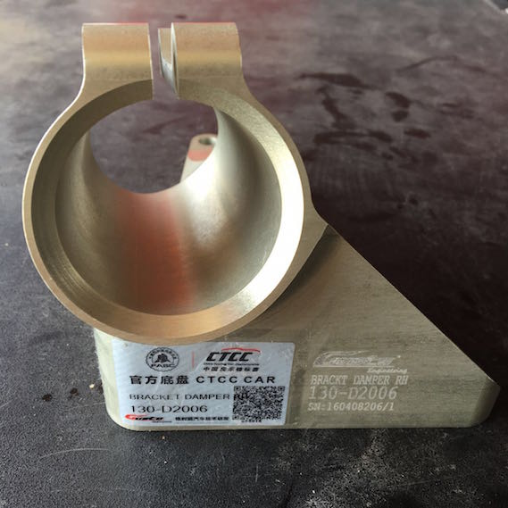 |  | 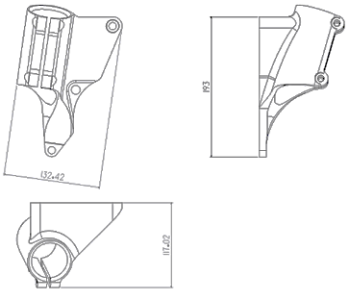
材质/Material |  | 铝合金
产品编号/Part No. | 130-D2006 | 最小重量/Min. weigh | 582.28 g
P5-34）车轮轴承– 拆下状态 P5-35）车轮轴承 – 编号标签
Bearing - Dismounted Bearing - Label
产品编号/Part No. | 130-D1010 | 最小重量/Min. weigh | 1341 g
P5-36）车轮法兰 – 拆下状态 P5-37）车轮法兰 – 编号标签
HUB ASSY WELEDE - Dismounted HUB ASSY WELEDE - Label
产品编号/Part No. | 130-D1009 | 最小重量/Min. weigh | 1650.4 g

P5-38）车轮螺栓 – 拆下状态 P5-39）车轮螺栓 – 编号标签
Wheel bolt - Dismounted Wheel bolt - Label
产品编号/Part No. | 130-D1008 | 最小重量/Min. weigh | 100 g
P5-40）下摇臂座 – 拆下状态 P5-41）下摇臂座 – 编号标签
Wish bone bracket - Dismounted Wish bone bracket - Label

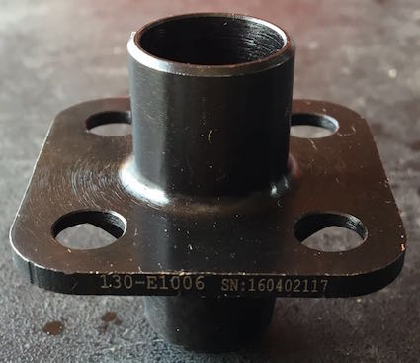
产品编号/Part No. | 130-E1006 | 最小重量/Min. weigh | 85 g

P5-42）后拉杆座 – 拆下状态 P5-43）后拉杆座 – 编号标签
Toe link bracket - Dismounted Toe link bracket - Label
产品编号/Part No. | 130-K3013 | 最小重量/Min. weigh | 84.22 g
P5-44）后拉杆 – 拆下状态 P5-45）后拉杆 – 编号标签
Toe link - Dismounted Toe link - Label
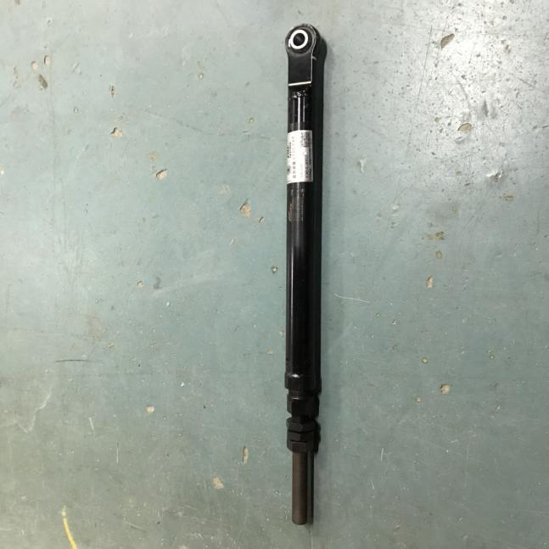 |  | 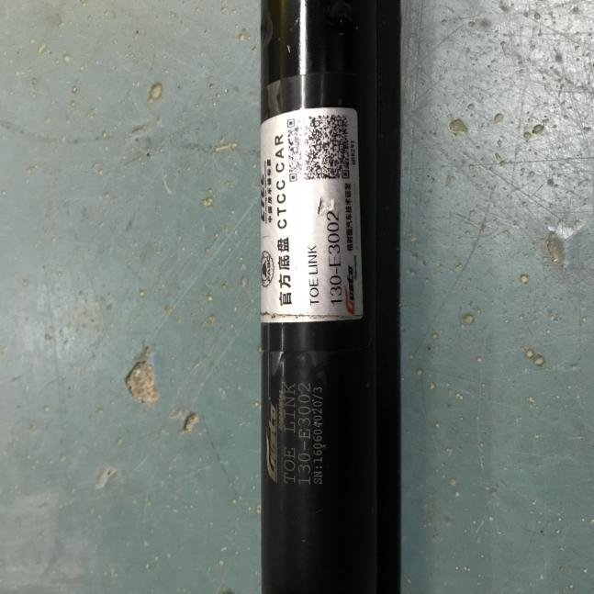
产品编号/Part No. | 130-E3002 | 最小重量/Min. weigh | 1126.4 g

P5-46）后防倾杆拉杆 – 拆下状态 P5-47）后防倾杆拉杆 – 编号标签
Rear arb arm - Dismounted Rear arb arm - Label
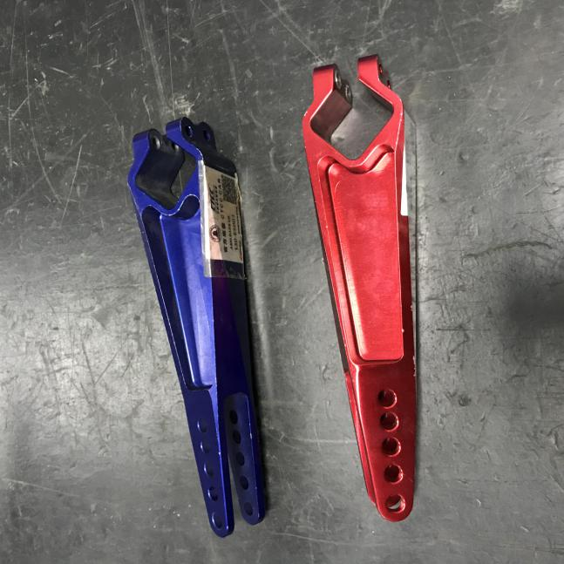 |  | 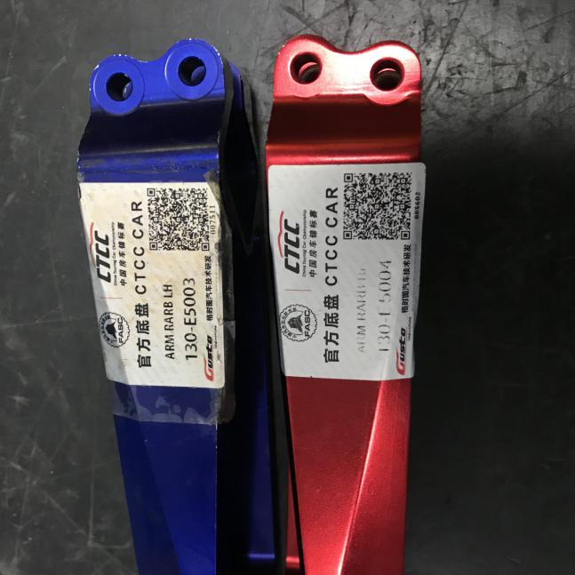
产品编号/Part No. | 130-E5003/130-E5004 | 最小重量/Min. weigh | 270.4/250.4 g
P5-48）刹车导风罩1 – 拆下状态 P5-49）刹车导风罩1 – 编号标签
Duct brake upright - Dismounted Duct brake upright - Label
 |  | 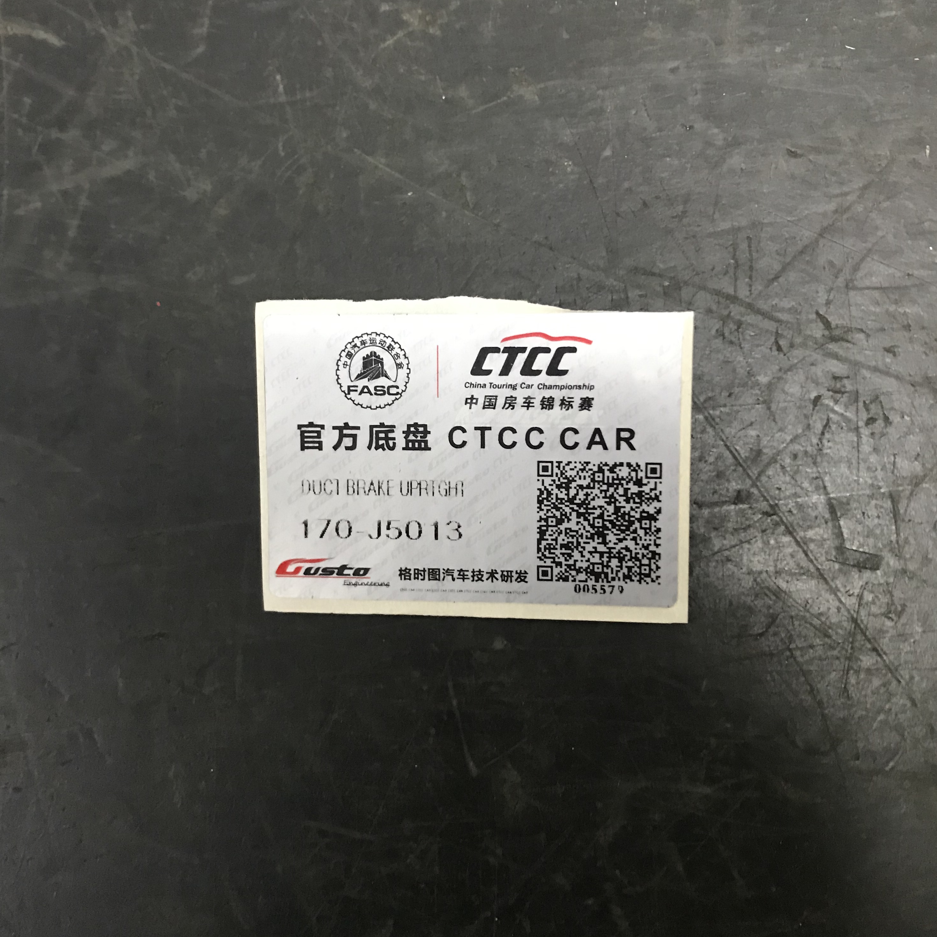
产品编号/Part No. | 170-J5013 | 最小重量/Min. weigh | 144.21 g

P5-50）刹车导风罩2 – 拆下状态 P5-51）刹车导风罩2 – 编号标签
Duct brake upright - Dismounted Duct brake upright - Label
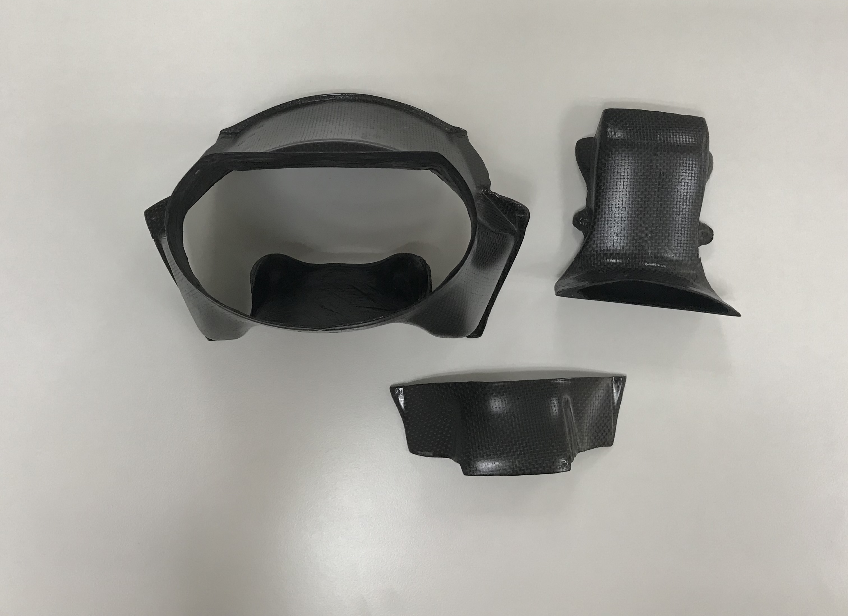 |  | 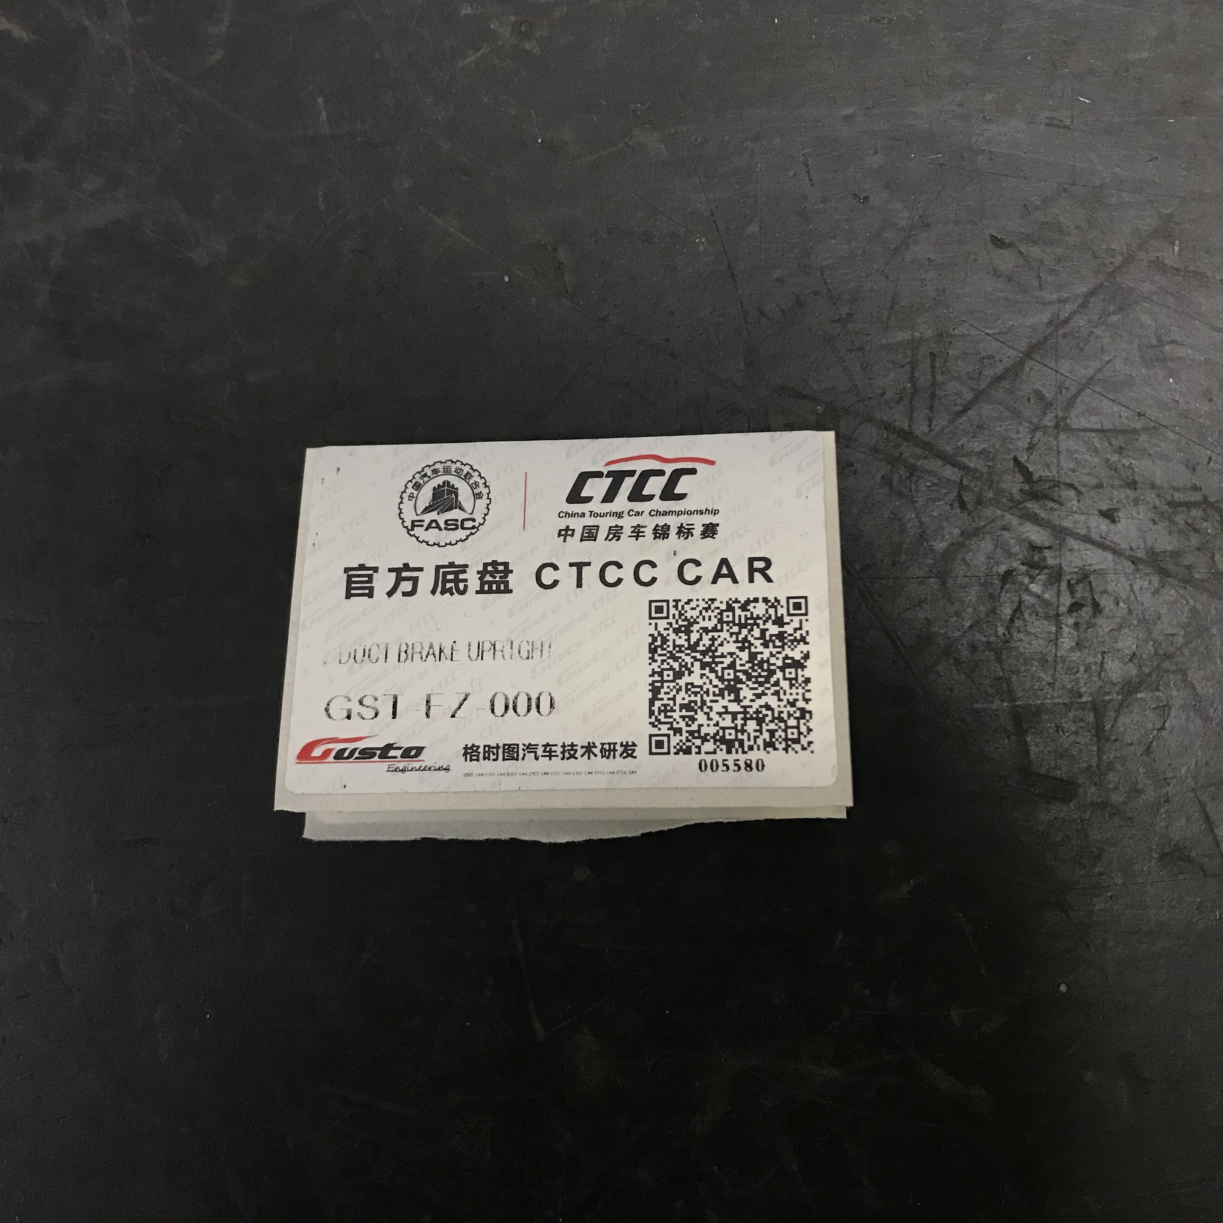
产品编号/Part No. | GST-FZ-000 | 最小重量/Min. weigh | 180.84 g

